1. Register Oracle account from <https://profile.oracle.com/myprofile/account/create-account.jspx>

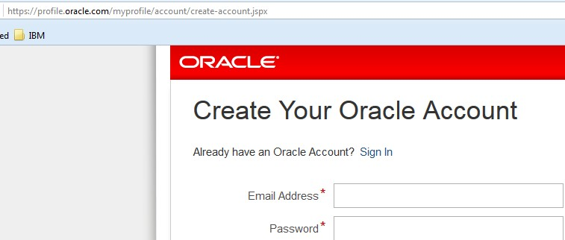

1. Download JDK 1.8.0\_92 from <http://www.oracle.com/technetwork/java/javase/downloads/jdk8-downloads-2133151.html>

C:\Users\IBM_ADMIN\AppData\Roaming\Tencent\Users\1095570977\QQ\WinTemp\RichOle\ALB5GPZL@5(0{5_4)(@09]B.jpg

1. Install JDK 1.8.0\_92

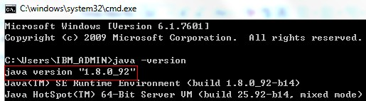

1. Download WebLogic 12.2.1.2 from <http://www.oracle.com/technetwork/middleware/weblogic/overview/index.html>

C:\Users\IBM_ADMIN\AppData\Roaming\Tencent\Users\1095570977\QQ\WinTemp\RichOle\`YEVQ]}I@__J5PH([P_M9(R.jpg

1. Unzip fmw\_12.2.1.2.0\_wls\_Disk1\_1of1.zip

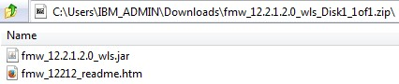

1. Unzip fmw\_12.2.1.2.0\_wls.jar

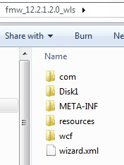

1. Install WebLogic

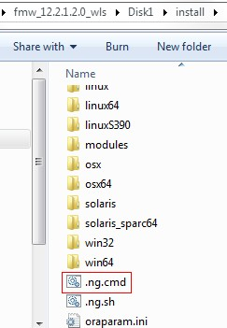

1. Installation done(created account as weblogic1/weblogic1, created domain as base\_domain)

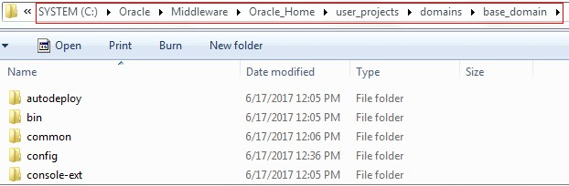

1. Start WebLogic

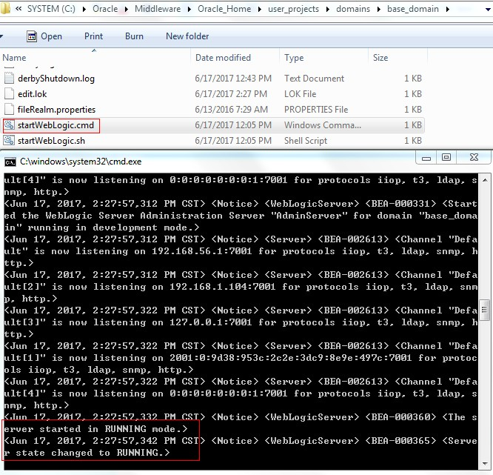

1. Login WebLogic Console

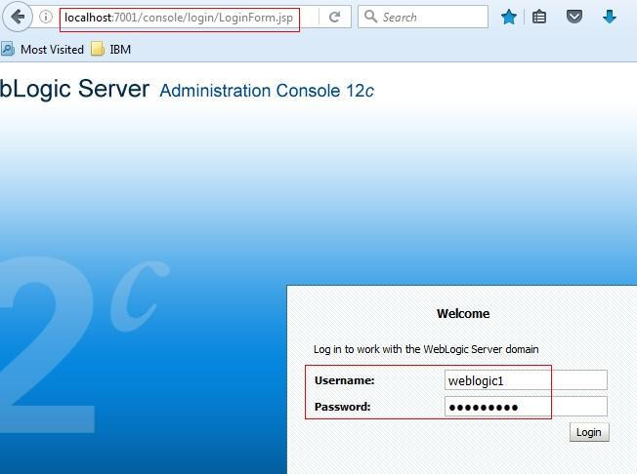

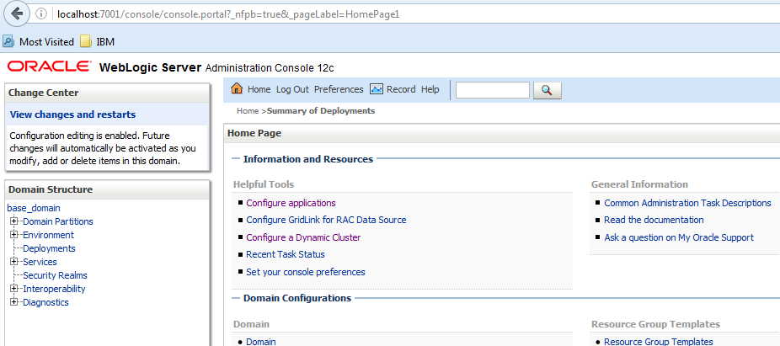

1. Create machine **Machine-0**

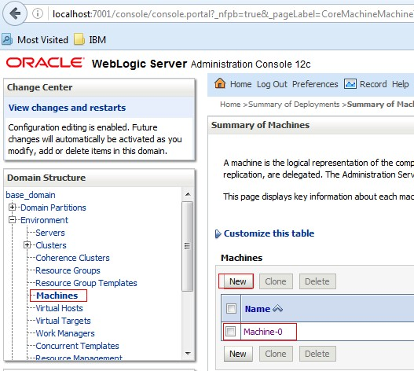

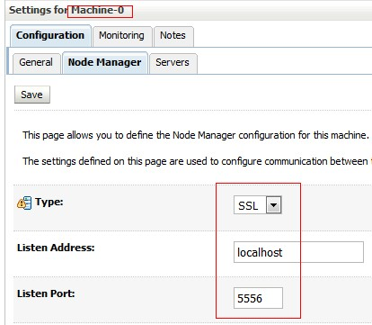

1. Create managed server **jenkins** and link it to machine **Machine-0**

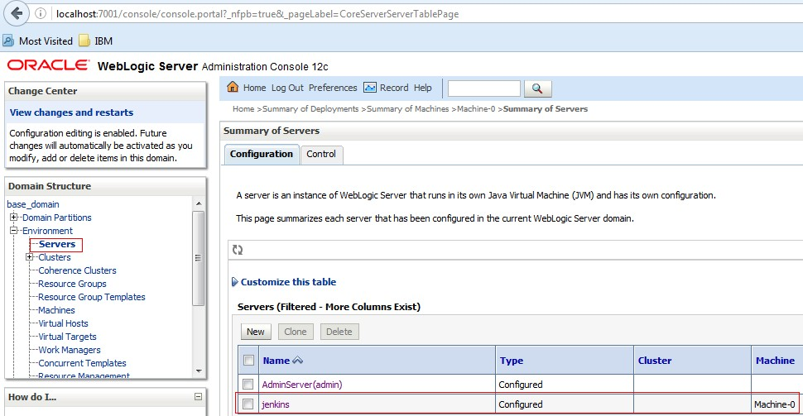

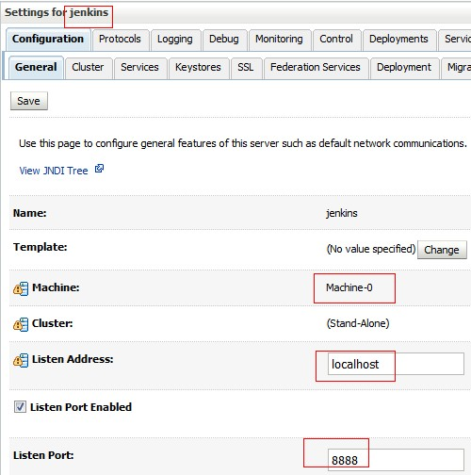

1. Start node manager

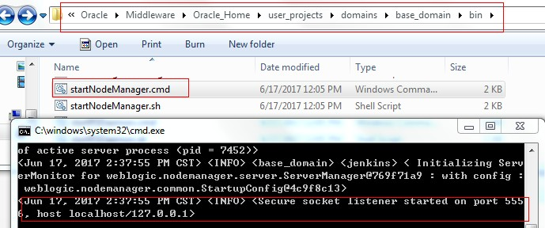

1. Start managed server **Jenkins**

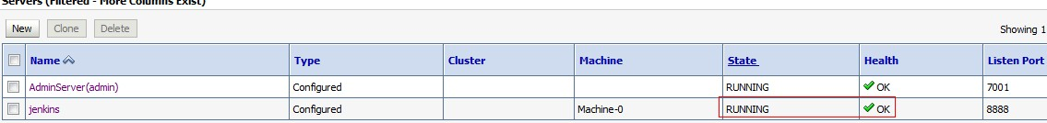

1. Download jenkins.war from <http://updates.jenkins-ci.org/download/war/2.65/jenkins.war>

C:\Users\IBM_ADMIN\AppData\Roaming\Tencent\Users\1095570977\QQ\WinTemp\RichOle\5UCLLR5Z3QE2{8JZQSI`S(R.jpg

1. Put weblogic.xml into jenkins.war\WEB-INF\



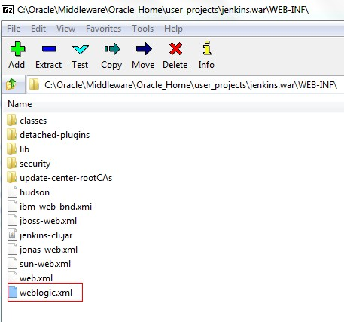

1. Install jenkins.war into WebLogic

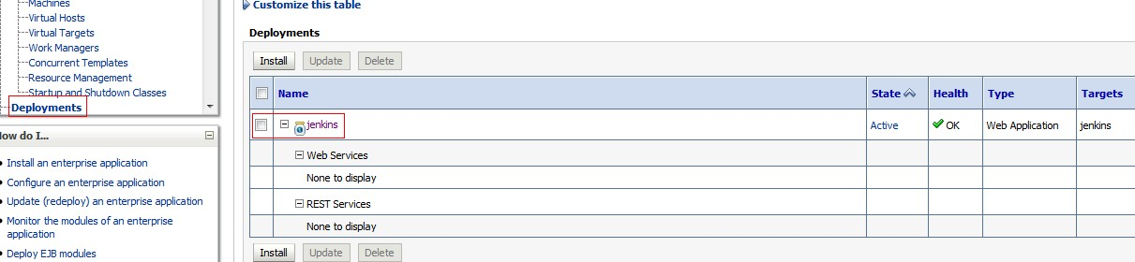

1. Access Jenkins (created account as jenkins1/jenkins1)

